Neural Network or Deep learning :
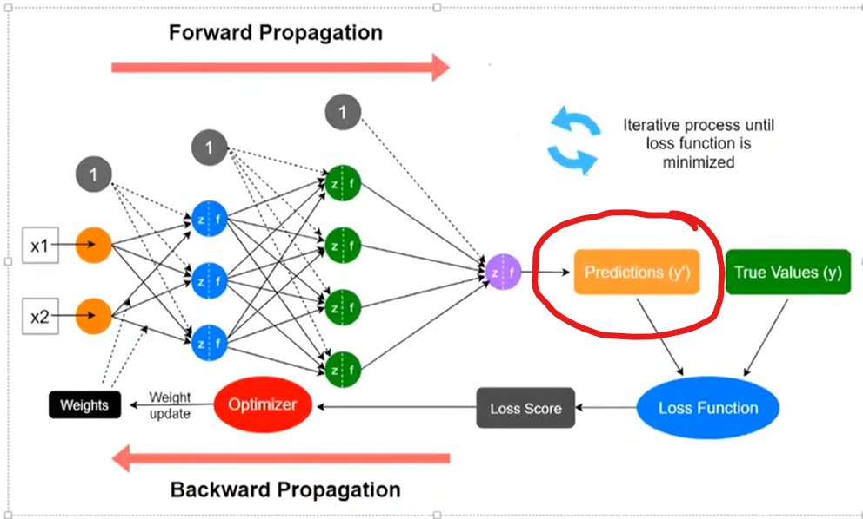
Why Forward propagation : once predicted then only we can adjust the prediction using loss function (, that is back propagation).
So one Epoch is, running the entire dataset one time (both Forward propagation and backward propagation).
Then shuffle and run more time, i.e. more Epoch.
Activation functions : https://www.geeksforgeeks.org/machine-learning/activation-functions-neural-networks/
Loss functions : https://www.geeksforgeeks.org/deep-learning/loss-functions-in-deep-learning/
https://www.geeksforgeeks.org/machine-learning/ml-common-loss-functions/
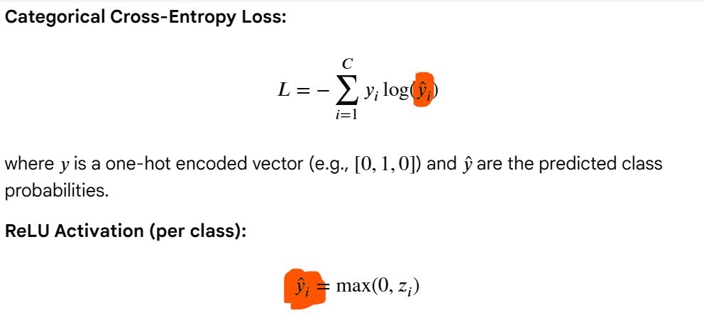
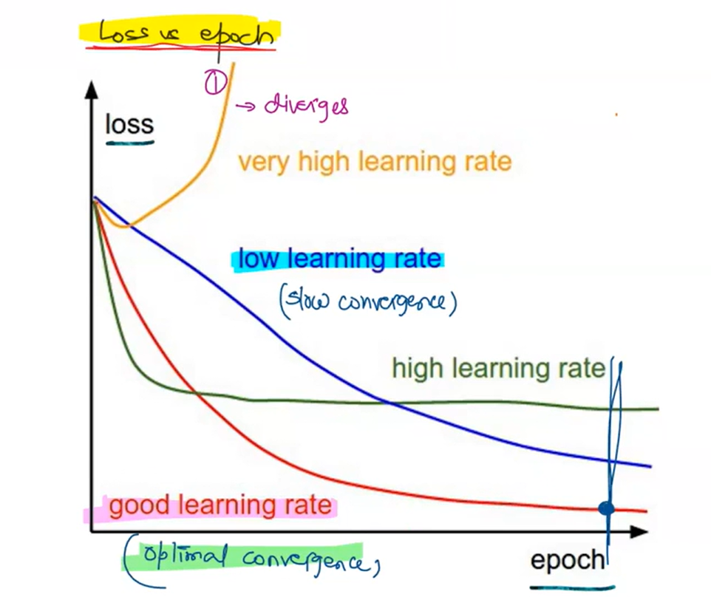
See good learning gives low cost value also, so better learning rate also helps to get lower cost , not only fast convergence (convergence - the minimum point in graph).
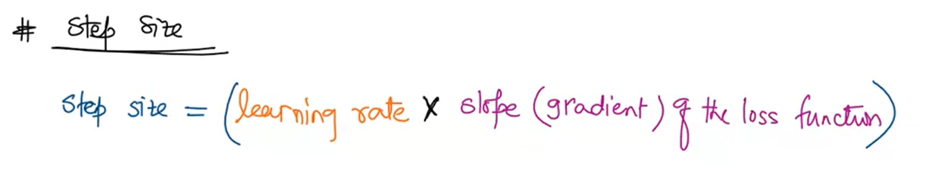
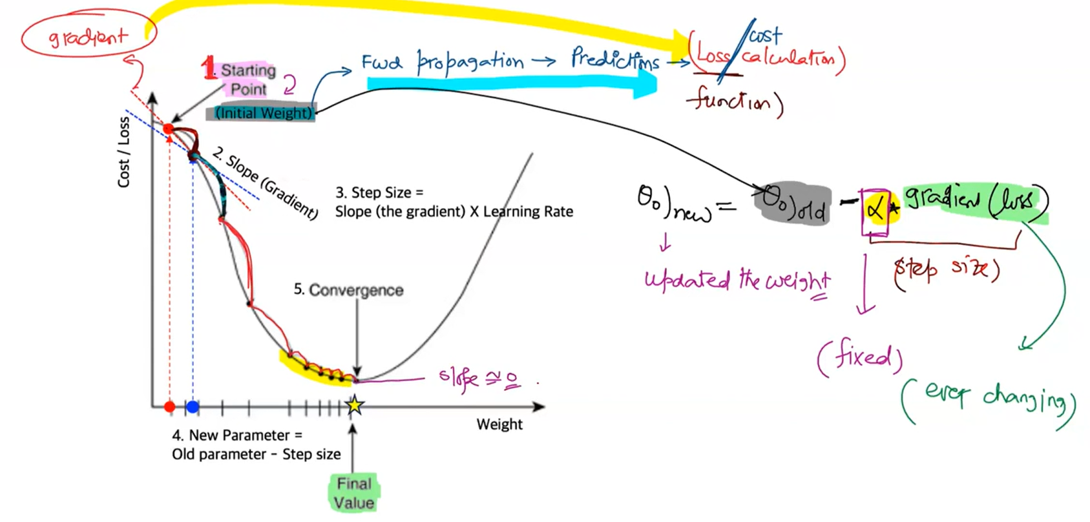
--
https://blog.dailydoseofds.com/p/an-intuitive-guide-to-non-linearity
Why is ReLU a Non-Linear Activation Function?
Why the number of neurons = representational capacity
Each neuron provides one basis direction in representation space.
More neurons ⇒
- more patterns can be represented
- finer distinctions
- higher risk of overfitting
neuron count is a hyperparameter –

? DOTMATRIX OF X and W gives similarity of pattern – ReLU is for non-linearity without ReLU it would be linear representation only, could not fit the non-linearity.
But, ReLU is just activation function and gives the scaler value to activate neuron – if this is just denoting the direction on the representation sub space. How pattern approximation happening in graph how this is representing the direction or pattern(i.e. the DailyDDS graph example). Think on this.
ANS : Because one ReLU is one Neuron, it is representing the just specific local direction. Even it is scaler value , it is the value of output of ReLU whose input is dotmatrix (i.e. weighted sum) of W.X(transpose) , the dotmatrix itself reveling the similarity linearly, the ReLU is the additional ensure the non-linearity representation , i.e. just a bend or direction change.
?ok, but it is max(0, x) it would always give the positive direction then how it would achieve the any function (as per Universal Approximation theorem) ,i.e. if the function pattern falls in the negative space of vector space(graph).
ANS: remember it is one neuron, it is just gives the direction of that specific pattern in the local (or subspace) , and even where ever it is in graph, these values further (or in final layer) adjusted with BIOS , remember bios is the intercept , may lift or down the particular piece of pattern (or sub-dimension or lower dimension).
Here, remember one ReLU is one neuron: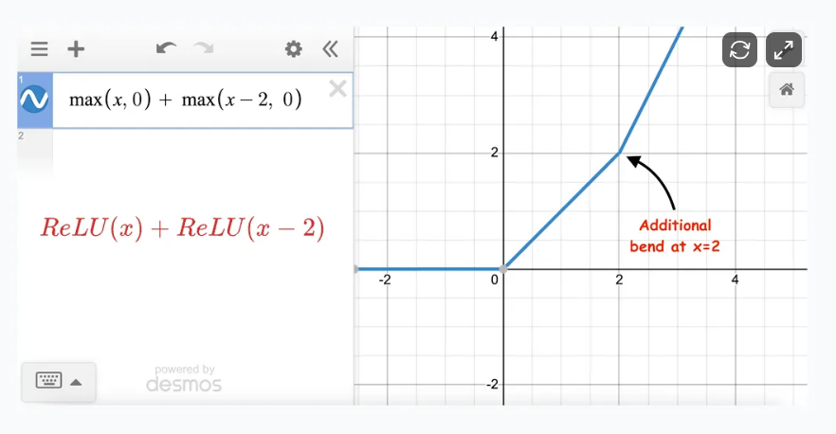

So it is just a function approximation , it is just distributed representation.
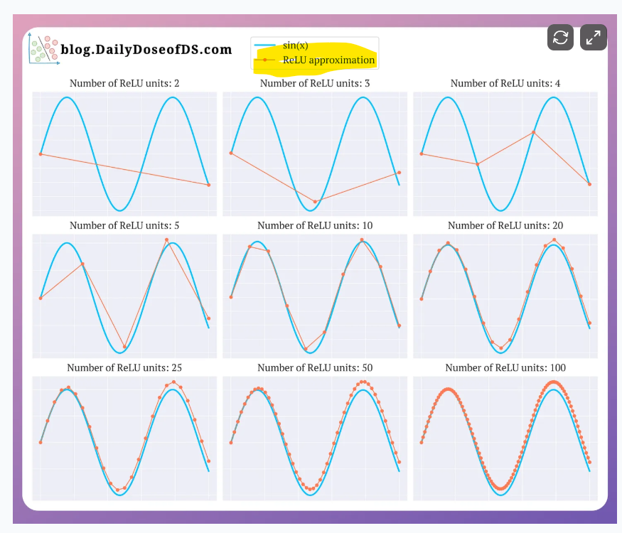

--
Remember , while back-propagation, each neurons weight and bios are tuned, because the goal is not only activating the right neuron, also we need to ensure deactivating or reducing the activation of other neurons which are not related to the specific i/p and o/p (either classification o/p or binary o/p, either way based on the final layer activation value , the result is decided ex: > 0.5 it is active, or highest activation value in o/p layer will be classified as result, like hand-written digit classification. )
Mini-batch gradient descent :
https://www.geeksforgeeks.org/deep-learning/mini-batch-gradient-descent-in-deep-learning/ :
Instead of updating weights after calculating the error for each data point (in stochastic gradient descent) or after the entire dataset (in batch gradient descent, the mean gradient used to update), mini-batch gradient descent updates the model’s parameters after processing a mini-batch of data. This provides a balance between computational efficiency and convergence stability.
In Mini-batch gradient descent, requires More Epochs: Since it doesn’t use the entire dataset at once it may require more epochs to converge compared to batch gradient descent.
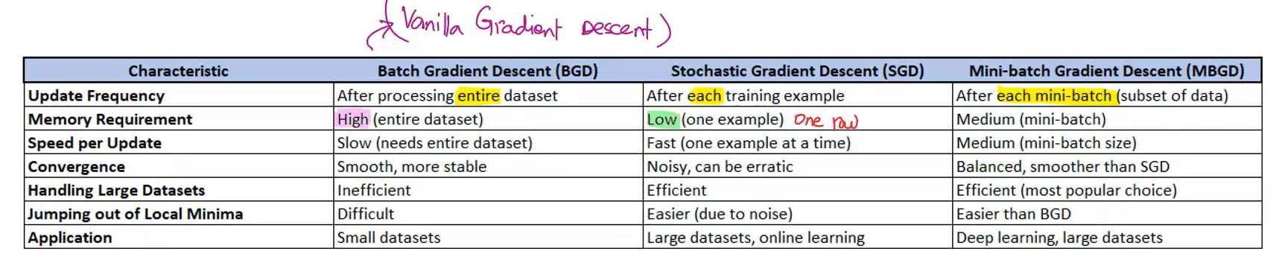

Single Layer Perceptron:
Perceptron is building block of neural network.
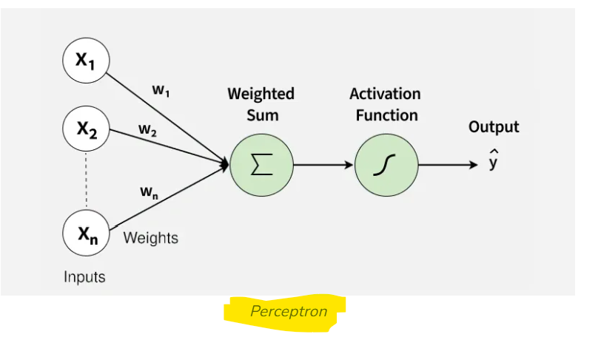

SLP archi
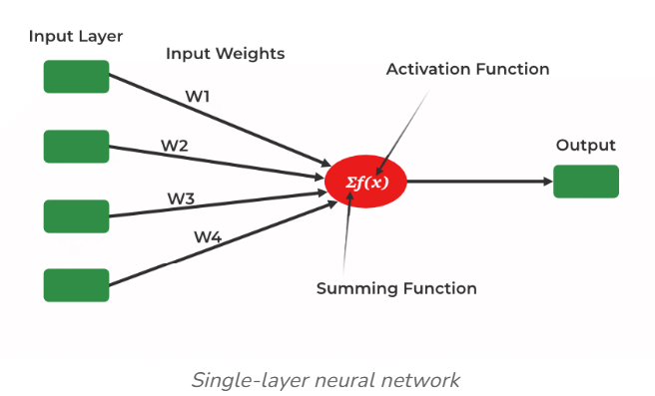
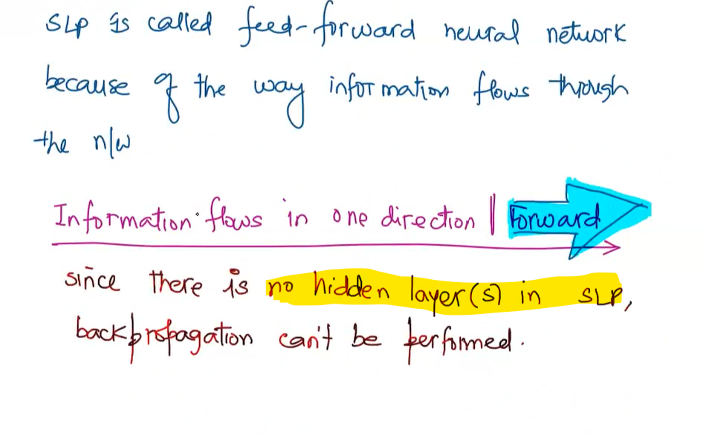

Multi Layer Perceptron: ANN with one or more hidden layers.

Softmax : convert the input into probability distribution (so, the result is b/w 0 and 1), used for multi-class classification.

Tensorflow and Keras :
TensorFlow - ML framework.
Keras - API to access ml framework like TensorFlow.
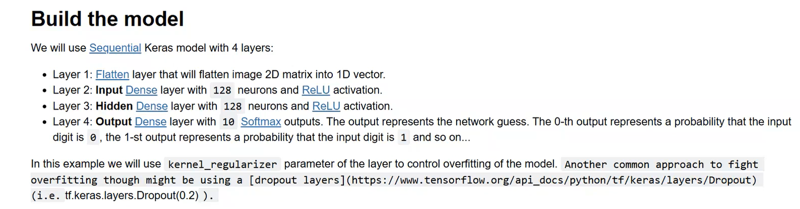
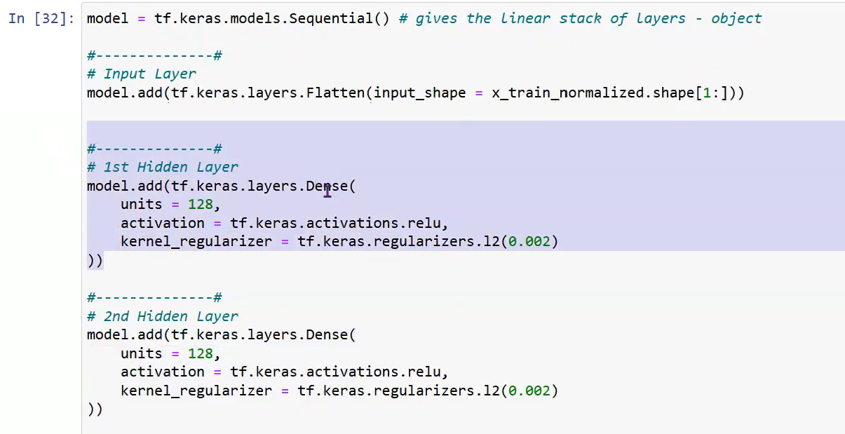
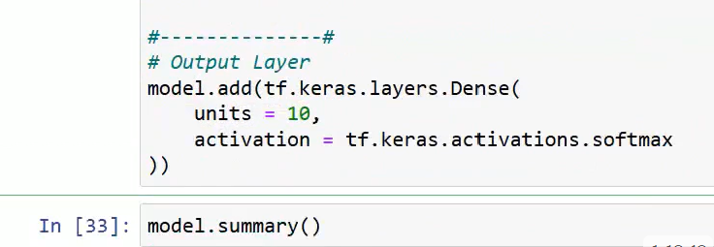
tf.keras.layers.Flatten() object is added as ip layer.
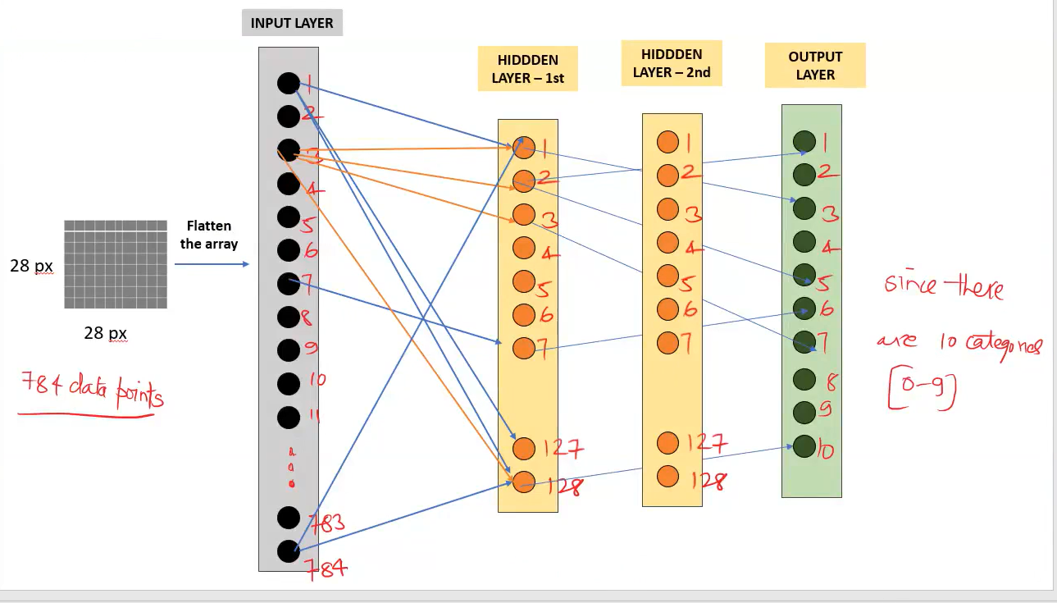

functional keras model :
callable instances in python : you can also create custom classes that produce callable instances. To do this, you can add the .__call__() special method to your class.
Here, instance call connects the layers:
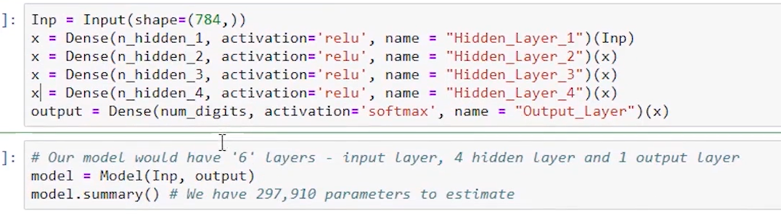

--
CONVULATIONAL NEURAL NETWORK
Convolution is Feature extraction for multi dim structured data (ex: image, video).
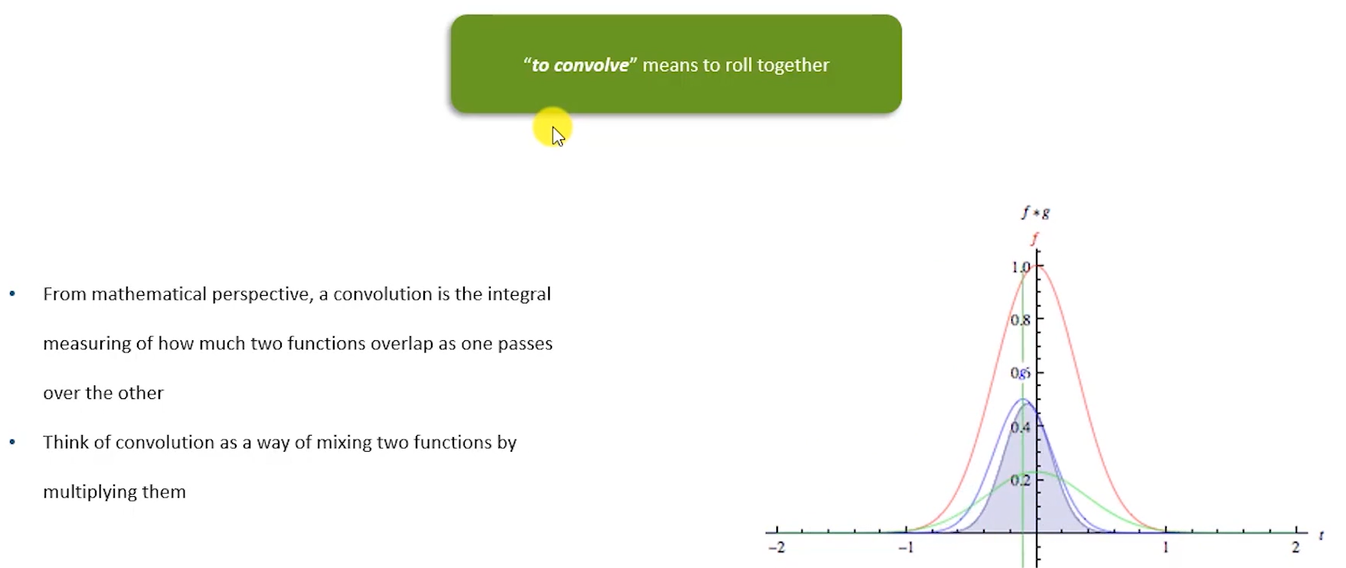
Remember, In continuous signal processing, convolution is defined as integral.
However, image is not continuous function,and since image is discreate function, the integral defined as summation. This is exactly Dot product.
A convolution kernel(filter) is just a weight matrix with special structure. And, It is learned during training using backpropagation.

(just think as, Invariance means not misclassifying even an image is rotated or shifted or squeezed, i.e. it considered as the same image.)
Equivariance : A function is equivariant if when the input changes in a certain way, the output changes in the same way: f(Tx)=T(f(x)) ; T = transformation (like shift) , f = function (like convolution)
So remember, Convolution is Translation Equivariant. Image → shift right by 1 pixel, then the feature map also shifts right by 1 pixel. So, the structure is preserved.
Invariance :A function is invariant if when the input changes, the output does NOT change. f(Tx)=f(x). when image rotate still the image considered as same image.
Convolution layers → preserve spatial structure (equivariance)
Pooling layers → reduce sensitivity to location
Fully connected / global pooling → create invariance
So, CNN pipeline : Equivariance → Compression → Invariance
So remember, feature map is the output convolution process (dot product or summation while rollover the filter on input image), so that feature map is the input for next layers:
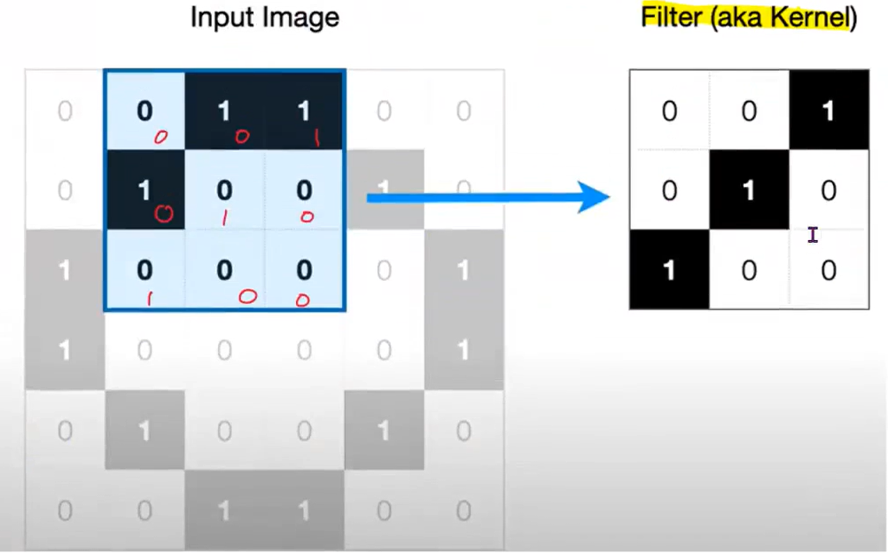
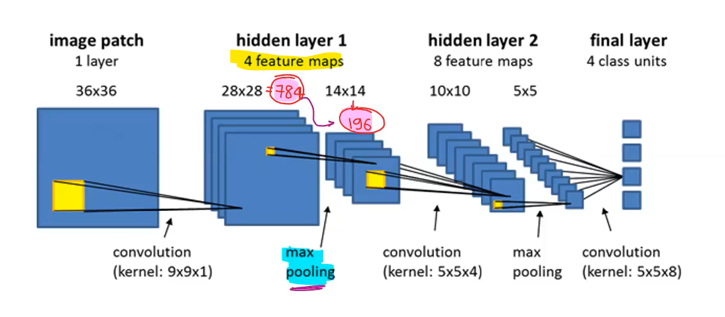
Why This Is Brilliant Design
If convolution were invariant from the beginning:
- We would lose spatial structure
- Model couldn’t learn shapes
If convolution were only equivariant:
- Final classifier would be too sensitive to exact position
CNN combines both intelligently.
Image segmentation Types:
- Semantic Segmentation: Classifies every pixel in an image into a specific category (e.g., road, sky, car).
- Instance Segmentation: Detects and delineates each distinct object instance within a class (e.g., separating "car1" from "car2")
- Panoptic Segmentation: Combines semantic and instance segmentation to classify all pixels (stuff) and detect individual objects (things).
Modern approaches use deep learning, specifically encoder-decoder architectures like Mask R-CNN or U-Net.
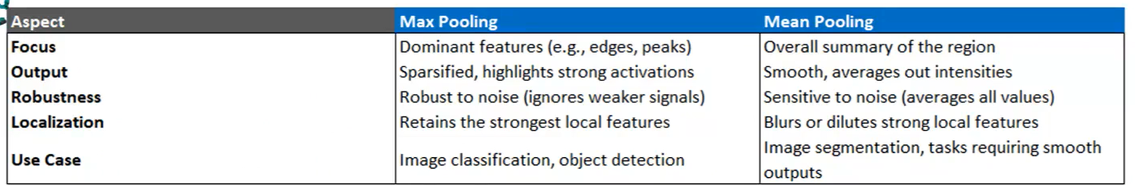
Batch Normalization (its just standard normalization the z-score) : applied in each hidden layer to prevent overfitting(?) and simplify the calculation: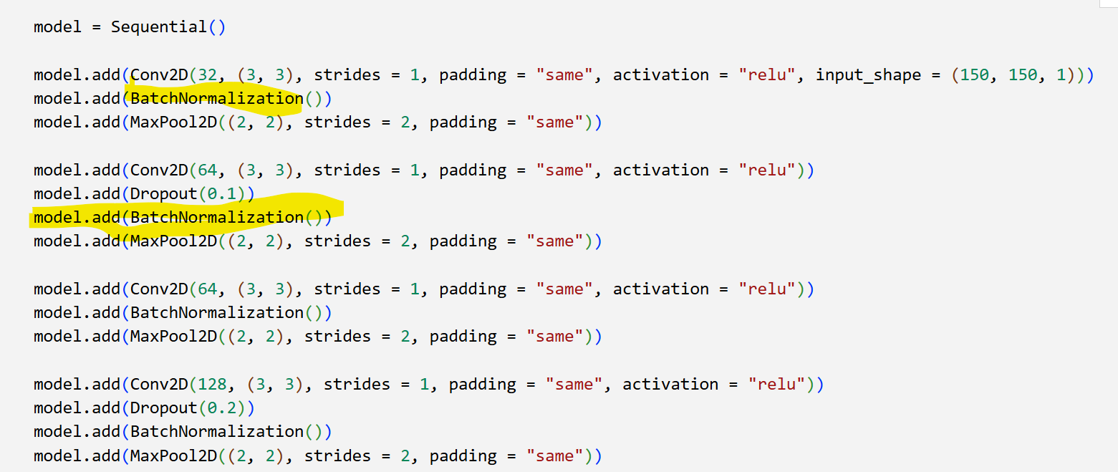
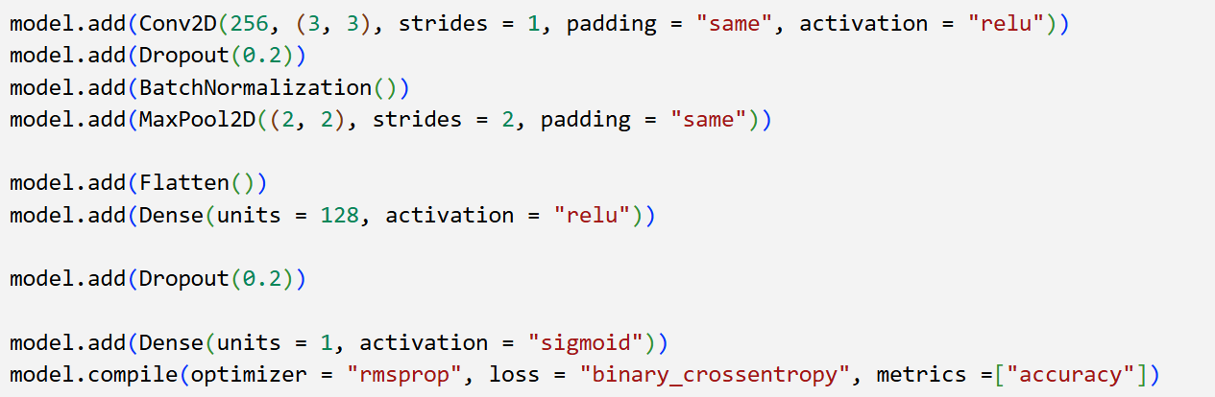
Strides (long step) – instead of move one step(default) to apply the convolution in the space of input feature, can skip the one or more columns and rollover the filter. So overfit prevented.
Strides are learnable downsampling technique, maxpool is non-learnable down sampling. Some designs use either one, some designs use both. Strides are expensive calculation than pooling (maxpooling, avgpools).
Dataset preprocess order: map → shuffle → batch → prefetch.
Using .batch() before .map(), i.e. wrong order can cause internal shape issues while train model.

Shearing(skewing) vs rotating (Data Agumentation) : Shear transformation is different from rotation. In shearing, one axis is fixed while the image is stretched along an angle, whereas rotation spins the entire image around a central point.

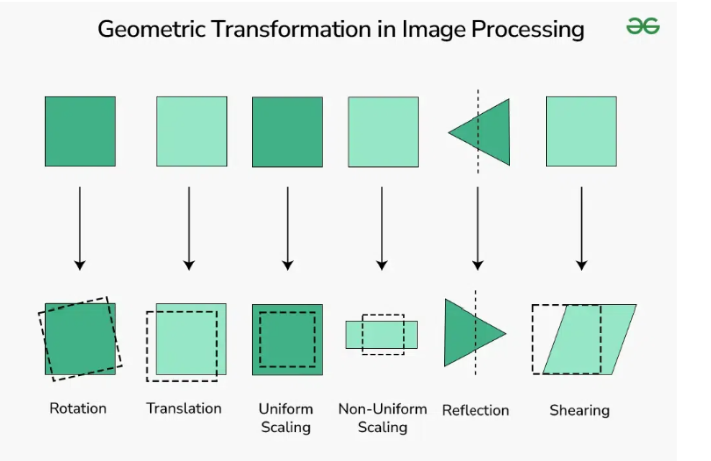
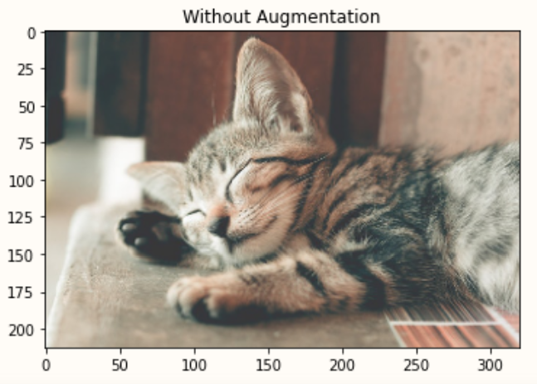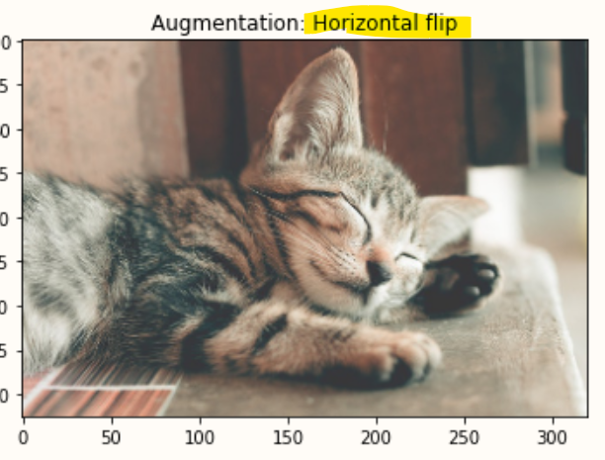horizontal flip.

--
Auto Encoders – Decoders
Recurrent Neural Network
LSTM
NLP
Transformers
GPT – Generative Pre-trained Transformer
--
Natural Language Processing:
Lemmatization vs Stemming : two common text normalization (word reducing) techniques.
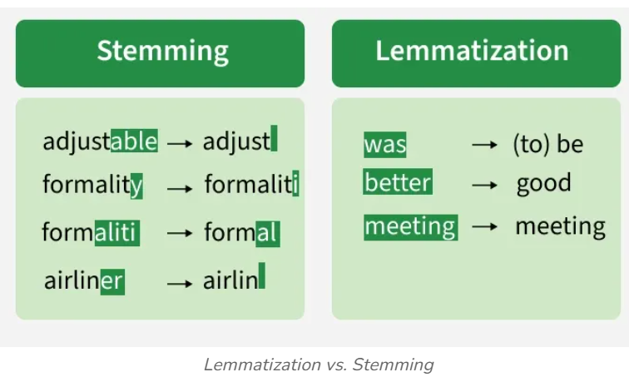
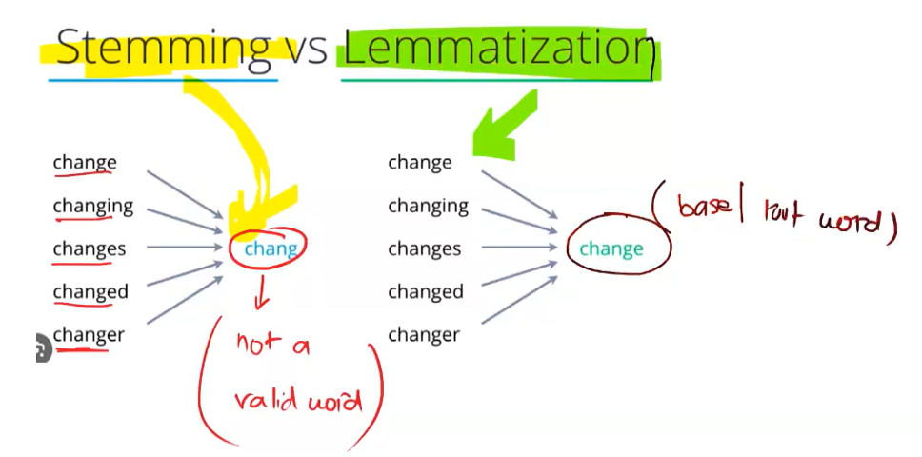

--
- Transfer Learning (Feature Extraction): You freeze all (or most) of the original model layers, treating them as a fixed feature extractor, and only train a new top-level classifier head.
- Fine-Tuning: After transfer learning, you unfreeze some or all of the top layers of the pretrained base model and continue training at a lower learning rate, allowing the base features to be modified for the new task.
--
Autoencoders – unsupervised feed-forward neural network algorithm that learn to compress data into low-dimensional representation (encoder) then reconstruct the input accurately(decoder).

--
